MACHINE LEARNING
Business Repayment Date Prediction

NAME OF THE STUDENTS :

1. Vismay Agarwal (19013440058)

2. Aayush Marwah (19013440001)

3. Pushkar Kumar (19013440033)

4. Shivansh Kumar Singh(19013440047)

5. Nadeem Ahmad (19013440028)



DEPARTMENT OF COMPUTER SCIENCE & ENGINEERING
R.V.S. COLLEGE OF ENGINEERING AND TECHNOLOGY
JHARKHAND UNIVERSITY OF TECHNOLOGY (JUT)


2019-2023
A
Project Report
On
Business Repayment Date Prediction

Submitted in partial fulfillment of the requirements
for
7th Semester
Bachelor of Technology in
Computer Science and Engineering
by
- Vismay Agarwal University Roll No- 19013440058
- Aayush Marwah University Roll No- 19013440001
- Pushkar Kumar University Roll No- 19013440033
- Nadeem Ahmad University Roll No- 19013440028
- Shivansh Kumar Singh University Roll No- 19013440047

Under the guidance of
Mr. RAHUL KUMAR
Asst. Professor (Dept. of Computer Science and Engineering)

Department Of Computer Science and Engineering
R.V.S. College of Engineering and Technology
Jamshedpur – 831012
2019 - 2023

Department of Computer Science and Engineering

CERTIFICATE

This is to certify that the project work entitled “Business Repayment Date Prediction” is done by Vismay Agarwal, Regd. No:- 19013440058 in partial fulfillment of the requirements for the 7th Semester Sessional Examination of Bachelor of Technology in Computer Science & Engineering during the academic year 2019-23. This work is submitted to the department as a part of evaluation of 7th Semester Project.

Asst. Professor Mr. Rahul Kumar Prof. Mr. Deobrata Kumar
Project Guide H.O.D, CSE

Signature of External

Date: 11th January, 2023
Place: RVSCET, Jamshedpur

DECLARATION

We declare that this written submission represents our ideas in our own words and where others ideas or words have been included. We have adequately cited and referenced the original sources. We also declare that we have adhered to all principles of academic honesty and integrity and have not misrepresented or fabricated or falsified any idea/data/fact/source in our submission. We understand that any violation of the above will cause for disciplinary action by the Institute and can also evoke penal action from the sources which have thus not been properly cited or from whom proper permission has not been taken when needed.

(Signature)
- Vismay Agarwal

(Signature)
- Aayush Marwah

(Signature)
- Pushkar Kumar

(Signature)
- Nadeem Ahmad

(Signature)
- Shivansh Kumar Singh

ACKNOWLEDGEMENT

We avail this opportunity to express our profound sense of gratitude to Asst. Prof. Rahul Kumar Sir for his/her constant supervision, guidance and encouragement right from the beginning till the completion of the project.

We wish to thank all the faculty members and supporting staffs of Dept. of Computer Science and Engineering for their valuable suggestions, timely advice and encouragement.

(Signature)
- Vismay Agarwal

(Signature)
- Aayush Marwah

(Signature)
- Pushkar Kumar

(Signature)
- Nadeem Ahmad

(Signature)
- Shivansh Kumar Singh

Content
- Introduction
- Purpose
- Project Scope
- Product Features
- System Analysis
  - Software Requirements
  - Hardware Requirements
- System Design & Specifications
High Level Design (HLD)
- Project Model
- Libraries Imported
- Structure Chart
- DFD
- E-R Diagram
- UML ( Use Case Diagram)
- Coding
- Sample Code
- Testing
- Unit Testing
- Integration Testing
- Conclusion & Limitations.
- Reference/Bibliography
INTRODUCTION
WHAT IS BUSINESS REPAYMENT DATE PREDICTION?
The two most critical questions in the BUSINESS industry are:
1) How risky is the borrower?
2) Given the borrower’s risk, should we lend him/her?
The answer to the first question determines the time the money is due and the time period borrower would have to repay the manufacturer. With lending date in mind, we can then determine when the borrower will pay for the products bought.
Manufacturers provide products to borrowers in exchange for the promise of repayment within a certain time frame. That means the manufacturer only makes money if the borrower pays off the loan. However, if he/she doesn’t repay the loan, then the manufacturer loses money.
We’ll be using publicly available data from LendingClub.com. The data covers the 50,000 transaction between a manufacturer and reputed companies like WalMart, Amazon etc FOR THE YEAR 2019. The date of purchase, promise date and clear date is provided to us for each borrower. Therefore, so we’ll address the second question indirectly by trying to predict if the borrower will repay the loan by its clear date or not.
We will address the following problems first.
- What to do with missing values.
- Techniques used with imbalanced classification problems.
- Illustrate how to build an ensemble model using two methods: blending and stacking, which most likely gives us a boost in performance.
DESCRIPTION OF FEATURES IN THE DATA SET:

business_code : Business code of manufacturing company
cust_number : Customer number of borrowing company
name_customer : Name of borrowing company
clear_date : Date when due amount is paid
buisness_year : Year of business transaction
doc_id : Identity Number for transaction document
posting_date : Date of transaction
document_create_date : Date of document creation for the transaction
due_in_date : Promised date for payment
invoice_currency : Currency in which payment is made
document_type : Format of transaction document
posting_id : Unique Identifier for Manufacturer
area_business : Country of borrower company
total_open_amount : Amount of money to be paid by borrower
baseline_create_date : Date of due date creation
cust_payment_terms : Mode of payment
invoice_id : Identifier for product invoice
isOpen: Verification for payment
PURPOSE:
A predictive model is a statistical technique using machine learning and data mining to predict and forecast likely future outcomes with the aid of historical and existing data. It works by analyzing current and historical data and projecting what it learns on a model generated to forecast likely outcomes. Predictive modeling can be used to predict just about anything, from TV ratings and a customer’s next purchase to credit risks and corporate earnings.
A predictive model is not fixed; it is validated or revised regularly to incorporate changes in the underlying data. In other words, it’s not a one-and-done prediction. Predictive models make assumptions based on what has happened in the past and what is happening now. If incoming, new data shows changes in what is happening now, the impact on the likely future outcome must be recalculated, too. For example, a software company could model historical sales data against marketing expenditures across multiple regions to create a model for future revenue based on the impact of the marketing spend.
Most predictive models work fast and often complete their calculations in real time. That’s why banks and retailers can, for example, calculate the risk of an online mortgage or credit card application and accept or decline the request almost instantly based on that prediction.
Our project aims to predict the likely date when the borrower may return the amount due on the product he took from the manufacturer in advance using this predictive model in machine learning using various algorithms like linear regression, decision tree, random forest etc.
PROJECT SCOPE:
In a nutshell, predictive analytics reduce time, effort and costs in forecasting business outcomes. Variables such as environmental factors, competitive intelligence, regulation changes and market conditions can be factored into the mathematical calculation to render more complete views at relatively low costs.
Examples of specific types of forecasting that can benefit businesses include demand forecasting, headcount planning, churn analysis, external factors, competitive analysis, fleet and IT hardware maintenance and financial risks.
PRODUCT FEATURES:
In the business industry, manufacturers provide goods in loan in exchange for the promise of repayment on its sale. If the borrower repays the loan, then the lender would make earning. However, if the borrower fails to repay the loan, then the lender loses money or have to cease manufacturing operation. Therefore, lenders face the problem of predicting the risk of a borrower being unable to repay a loan or delay in repayment. In this study, the data from Lending club is used to train several Machine Learning models to determine if the borrower has the ability to repay its loan within promised time. In addition, we would analyze the performance of the models (Random Forest, Logistic Regression, Sup-port Vector Machine, and K Nearest Neighbors). As a result, logistic regression model is found as the optimal predictive model and it is expected that Fico Score and annual income significantly influence the forecast.

SYSTEM ANALYSIS
SOFTWARE REQUIREMENT:

- OS REQUIREMENT: WINDOWS 7 OR ABOVE, MAC OS
- ANACONDA NAVIGATOR
- JUPYTER NOTEBOOK

HARDWARE REQUIREMENT:
- RAM: 4GB OR ABOVE
- STORAGE: 256GB SSD OR ABOVE, 256GB HDD OR ABOVE


STEP 1: OPEN ANACONDA NAVIGATOR
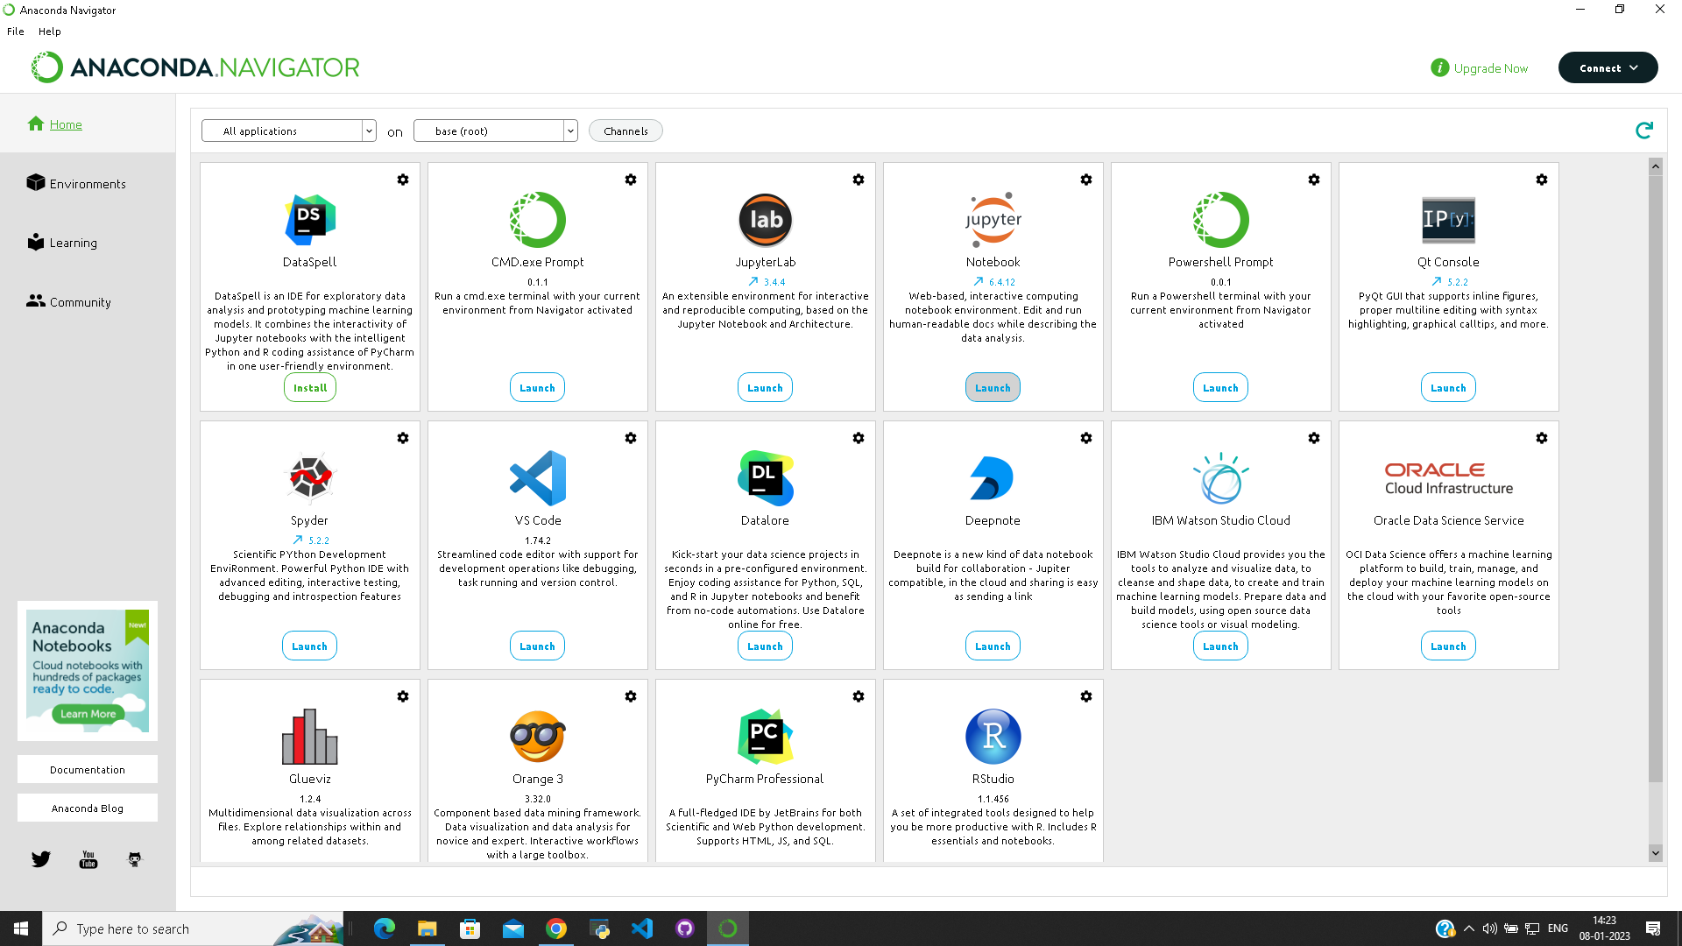
STEP 2: OPEN JUPYTER NOTEBOOK

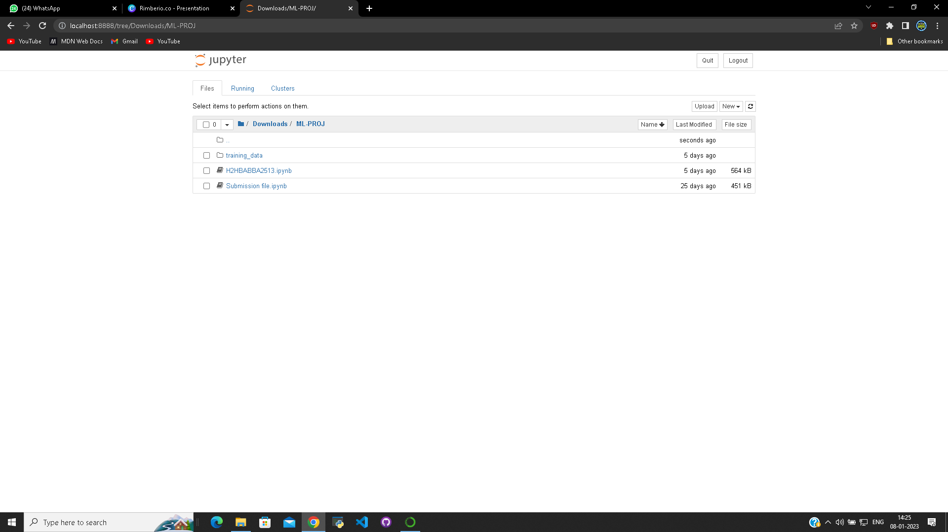
STEP 3: NAVIGATE TO YOUR PROJECT LOCATION AND OPEN IT

SYSTEM DESIGN & SPECIFICATIONS
PROJECT MODEL:
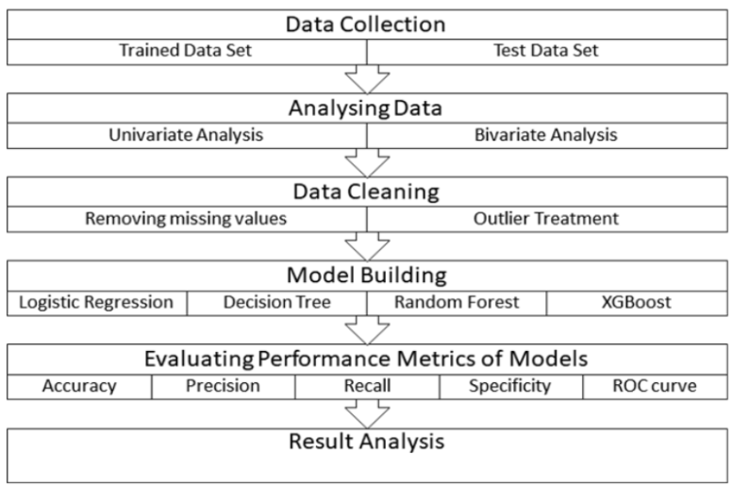
LIBRARIES IMPORTED:
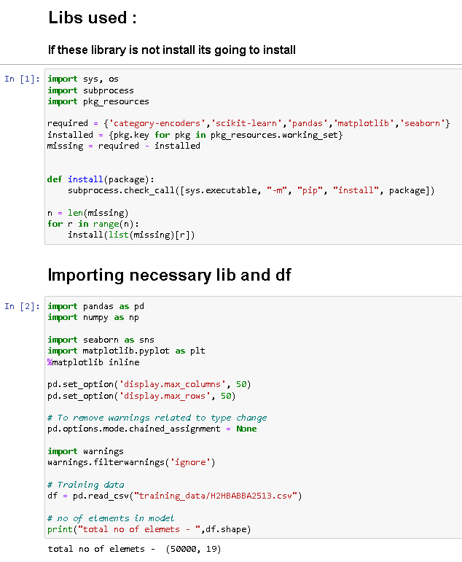
STRUCTURE CHART:
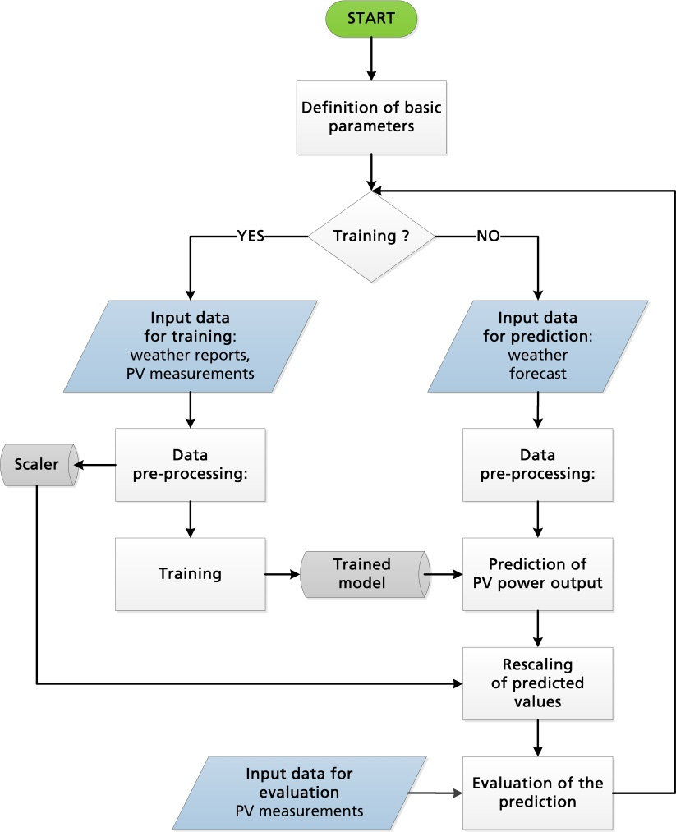

DATA FLOW DIAGRAM:
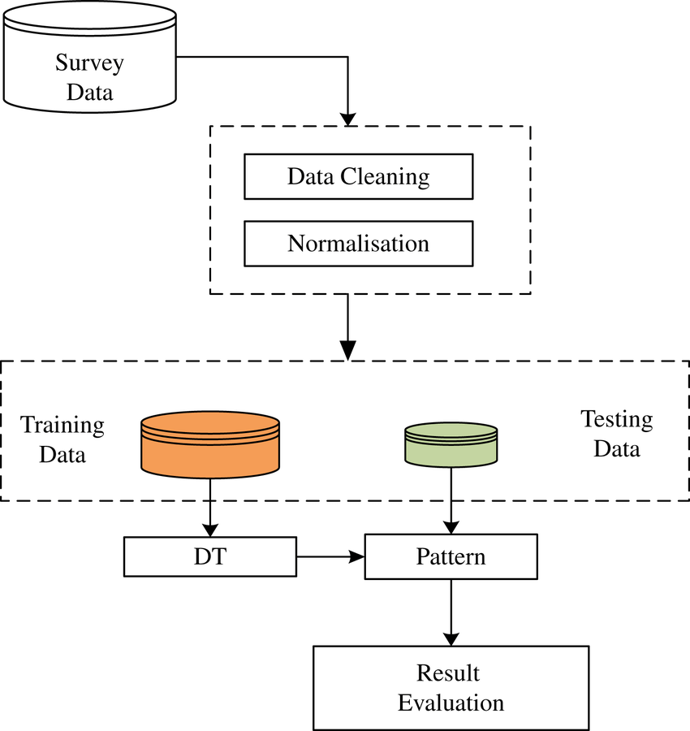

ENTITY RELATIONSHIP DIAGRAM:
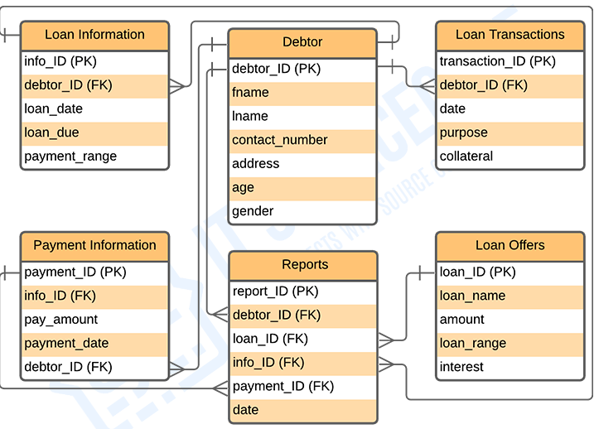

UML DIAGRAM:
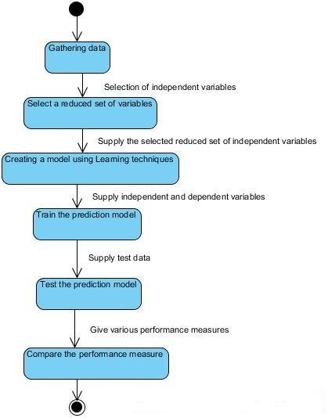

CODING
METHODS:

- Null Implification
- Pre Processing
- Feature Engineering
- Exploratory Data Analysis
- Encoding
- Feature Selection
- Linear Regression
- Decision Tree
NULL IMPLIFICATION:
Removing null columns in data frames since they cause data leaks and inconsistency.
Finds null columns in data set. Returns true for parameter if null column is found, else returns false. If a null column parameter is found, we drop that parameter i.e, remove it from data set.
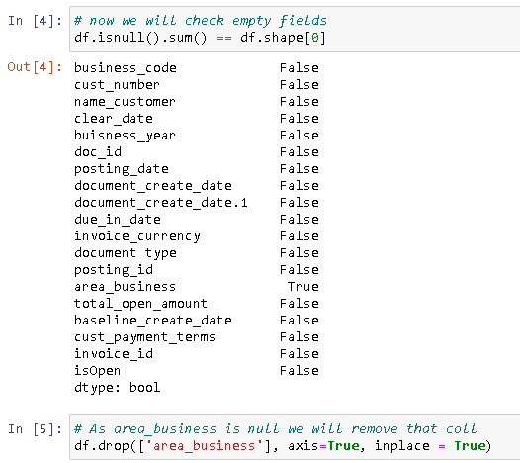
PRE PROCESSING:
Converts non readable, i.e, non int or float target and associate data frames into readable dataframes. We do so by using regular expressions. Here our dataframe is date, month and year. Using datetime library of python we implement pre-processing.
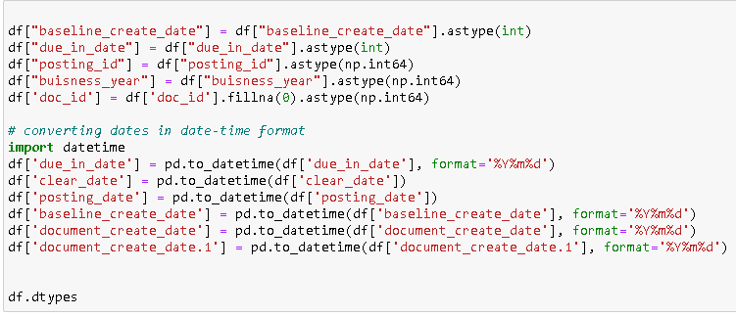

FEATURE ENGINEERING:
After pre processing, we have date, month and year of due_in_date, posting_date and clear_date. Instead of storing all 3 in new columns, we will find the difference in days between all 3 results to establish a relationship b/w them. In order to do so, we will split all dates according to their their 3 respective column days/month/year and instead of saving in new variables, we will delay this process to find difference in single unit i.e., number of days. This saves useless storage that would have been occupied otherwise.

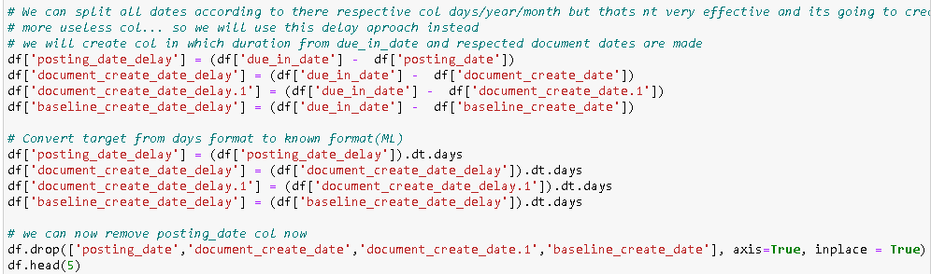

EXPLORATORY DATA ANALYSIS:
EDA is used to analyze and investigate data sets and summarize their main characteristics, often employing data visualization methods.
We use displot and boxplot on training data set to find outliers by visualizing using these graphs. After identifying outliers, we use scatterplot to check if there are any trend in the data set. If we find any unique dataframes, we can drop it since it won't affect the prediction.
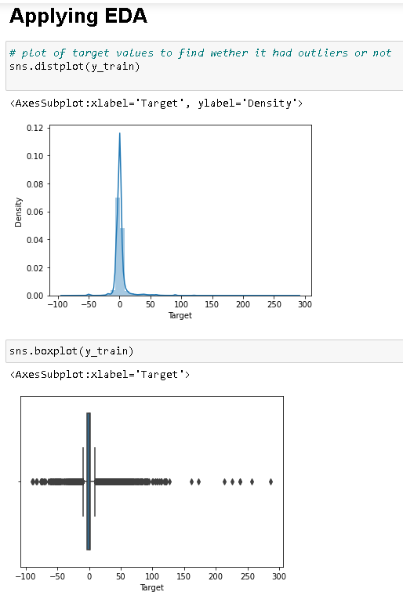
HANDLING OUTLIERS IN EDA:

There are way too many outliers in this dataset we can't delete all of them as they are necessary for our model. But instead we are going to seat a min/max range and we are going to delete data beside it to increase efficiency of model. The range that we are going to select is 70 acc to boxplot.

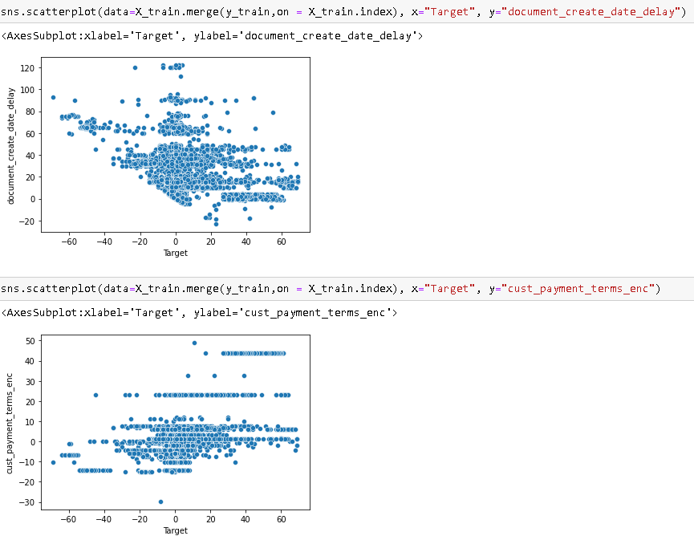

ENCODING:

Now that we have all necessary dataframes, we will try and convert these dataframes into machine readable data i.e, into integer type. This is done using encoding. We have implemented label encoding here. We are applying label encoding on data frames that are in object type.
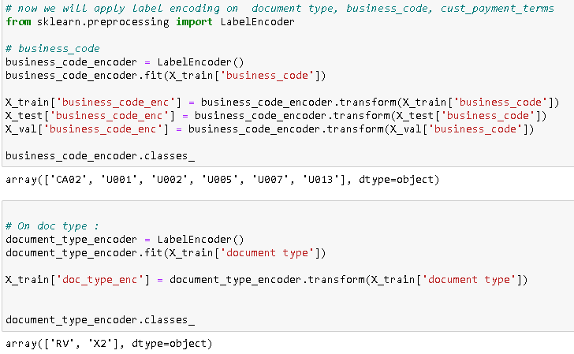
FEATURE SELECTION:
We will now search for co-relation in train dataset using heatmap. We will drop highly corelated items that have a corelation of over 90%. Next we will find variance in these corelation and drop unique dataframes.

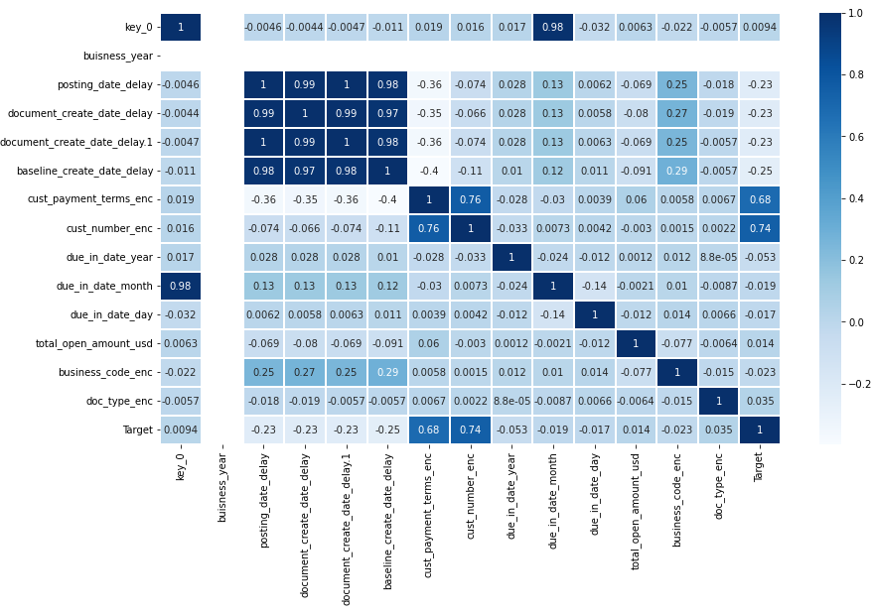
LINEAR REGRESSION:
Using linear regression algorithm, we will now find accuracy between train dataset and prediction data set. Through the lineplot graph we can see the disturbance between the two data set. According to the graph and result, the accuracy is only 59.99%.

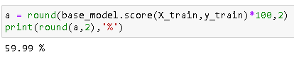

We can see in the axessubplot graph that there are data leaks in the linear regression of the train dataset hence, it causes the low accuracy in prediction.

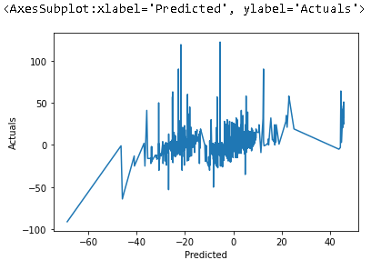
DECISION TREE:
Using decision tree regression algorithm, we will now find accuracy between train dataset and prediction data set. Through the lineplot graph we can see the disturbance between the two data set is better than in linear regression. According to the graph and result, the accuracy is over 99%. Hence we will use decision tree algorithm and our project is a success.
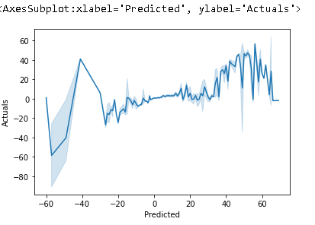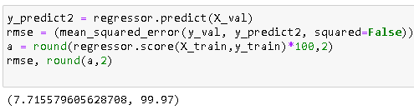
Here we notice that the accuracy is well over 99% as well as the axessubplot shows more consistent graph compared to in linear regression.

TESTING
UNIT TESTING:

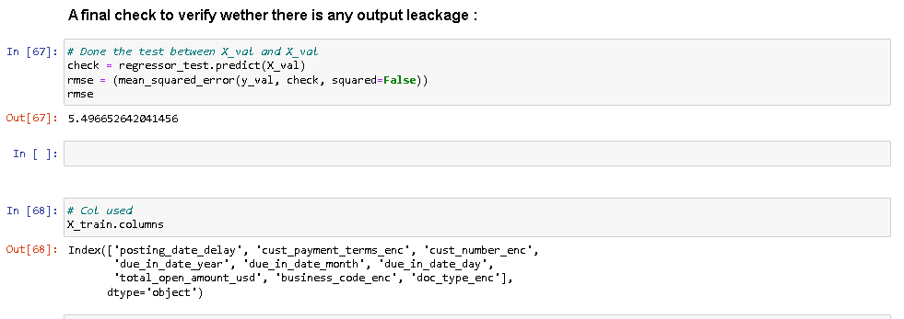

INTEGRATION TESTING:

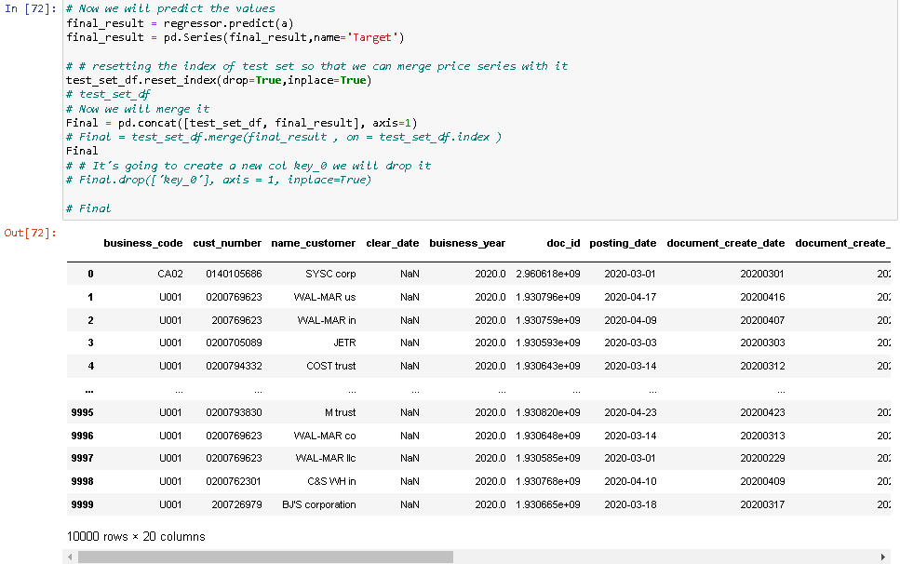

CONCLUSIONS & LIMITATIONS

CONCLUSIONS:
We did Exploratory data Analysis on the features of this dataset and saw how each feature is distributed.
We did bivariate and multivariate analysis to see imapct of one another on their features using charts.
We analyzed each variable to check if data is cleaned and normally distributed.
We cleaned the data and removed NA values
We also generated hypothesis to prove an association among the Independent variables and the Target variable. And based on the results, we assumed whether or not there is an association.
We calculated correaltion between independent variables and found that applicant clear_date and posting_date have significant relation.
We created dummy variables for constructing the model
We constructed models taking different variables into account and found through odds ratio that due_in_date, posting_date & baseline_create_date are creating the most impact on target decision
Finally, we got a model with days count as independent variable with highest accuracy in random forest algorithm.
We tested the data and got the accuracy of 99.97 %.
The techniques for testing the relationship between two variables are correlation and linear regression. Correlation quantifies the strength of the linear relationship between a pair of variables, whereas regression expresses the relationship in the form of an equation. In this article, we have used simple examples and SPSS and excel to illustrate linear regression analysis and encourage the readers to analyze their data by these techniques.
LIMITATIONS:
A company that wishes to utilize data-driven decision-making needs to have access to substantial relevant data from a range of activities, and sometimes big data sets are hard to come by. Even if a company has sufficient data, critics argue that computers and algorithms fail to consider variables—from changing weather to moods to relationships—that might influence customer-purchasing patterns when anticipating human behavior.

Time also plays a role in how well these techniques work. Though a model may be successful at one point in time, customer behavior changes with time and therefore, a model must be updated. The 2008 financial crisis exemplifies how crucial time consideration is because invalid models were predicting the likelihood of mortgage customers repaying loans without considering the possibility that U.S. housing prices might drop.

A thorough understanding of predictive analytics can help you with business forecasting, deciding when and when not to implement predictive methods into a technology management plan, and managing data scientists.

BIBLIOGRAPHY & REFERENCES:
In making of this project we took help from various website, book, research, project and journals.
They are as follows:

WEBSITES:
https://www.netsuite.com/portal/resource/articles/financial-management/predictive-modeling.shtml
https://www.sas.com/en_gb/insights/articles/analytics/a-guide-to-predictive-analytics-and-machine-learning.html
https://insightsoftware.com/blog/top-5-predictive-analytics-models-and-algorithms/
https://towardsdatascience.com/predicting-loan-repayment-5df4e0023e92

BOOKS:
APPLIES PREDICTIVE MODELING
By Max Kuhn, Kjell Jhonson

HANDS-ON PREDICTIVE ANALYTICS WITH PYTHON
By Alvaro Fuentes

JOURNAL:
Prediction and Analysis of Financial Default Loan Behavior Based on Machine
Learning Model
https://www.hindawi.com/journals/cin/2022/7907210/

PROJECT REFERENCE:
Walmart Sales Prediction - (Best ML Algorithms)
https://www.kaggle.com/code/yasserh/walmart-sales-prediction-best-ml-algorithms/

